**Title**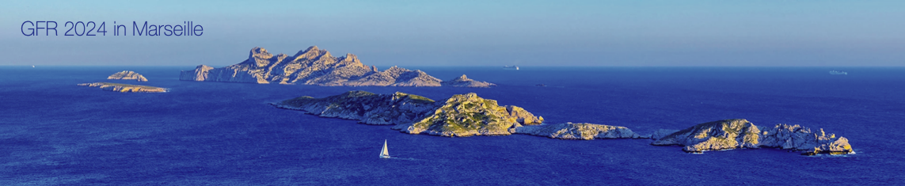

Author Name 1*, Author Name 2*, Speaker Name*

\**affiliations*

Speaker’s e*mail*

**Preference** : TALK or Poster & preferred session

**Keywords** (5 max):

______________________________________________________________________________

**Abstract** : (250 Words Max) Pour the flour, salt and sugar into a bowl. Add the crumbled yeast, lukewarm water, eggs, oil and orange blossom. Knead the dough well for 15 minutes. Form into a ball and leave to rest for 1 h in a sheltered place at room temperature. Roll out the dough to a thickness of 2 cm and cut into elongated 6 cm shapes. Plunge the chichi into the dough in small batches and cook for 5 min (turning if necessary to brown them on all sides). Drain and sprinkle with powdered sugar. Serve immediately.

______________________________________________________________________________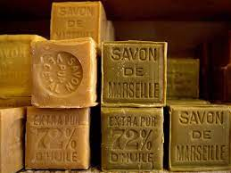

*Figure: Savon de marseille*